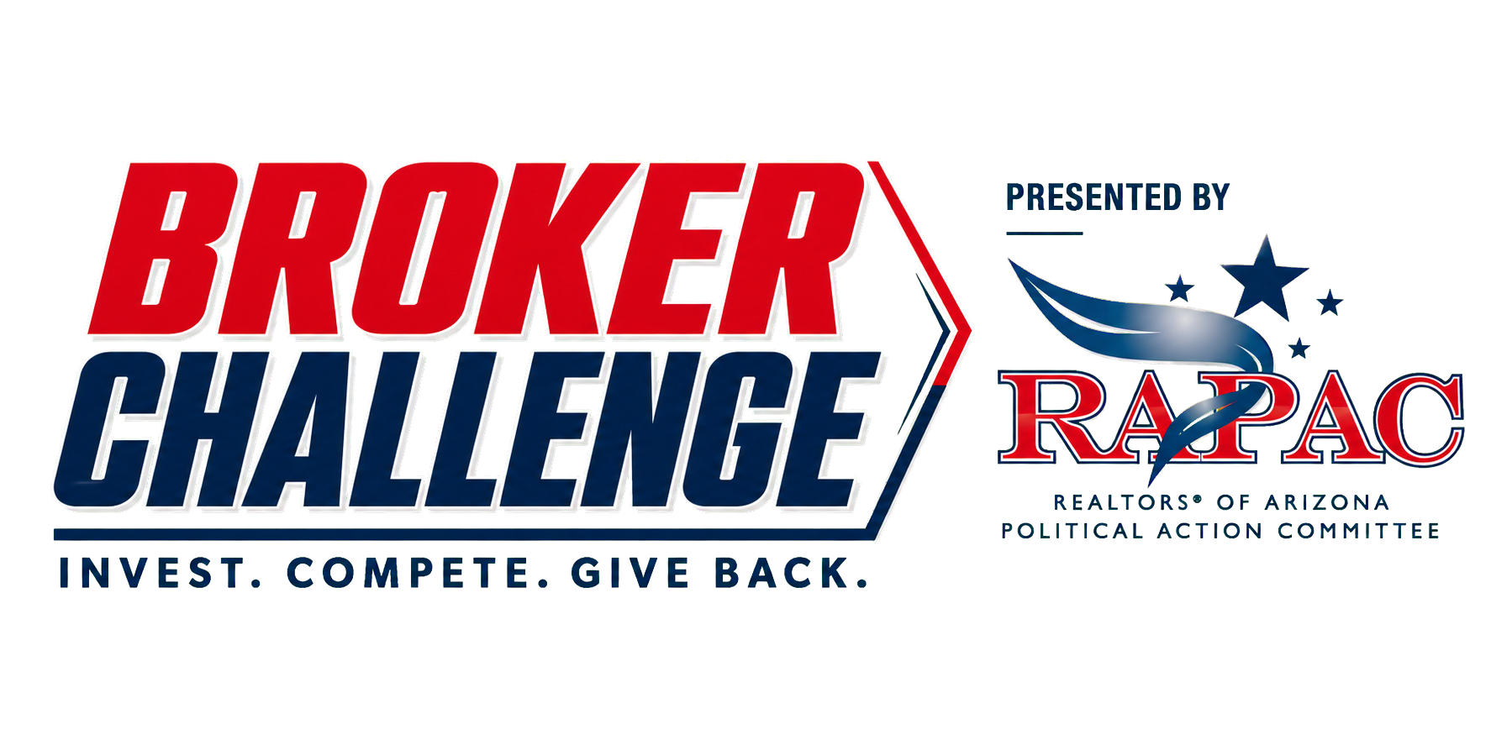
BROKER RULES AND ADMINISTRATION
October 1–30, 2026
The Tucson Association of REALTORS® sponsors and administers the 2026 RAPAC Broker Challenge. The goal is to add 225 TAR members making their first RAPAC contribution of 2026. These rules control if they conflict with a flyer, email, social post or verbal summary.
Campaign awards
Award | Eligibility and selection | Benefit
Individual drawing | Each new qualifying investor receives one entry. Additional dollars do not create additional entries. | $1,000 Amazon gift card
Division Champion | Highest qualifying participation rate in each division. Ties: new-investor total, then documented drawing. | Recognition and one entry in the Community Impact Award drawing
Community Impact Award | Equal-chance drawing among qualifying Division Champions. | $1,000 contribution in the recipient brokerage’s name to an approved charity

Who counts as a new qualifying investor
A TAR member in good standing who had no 2026 RAPAC contribution credited before October 1, contributes at least $30 between 12:01 a.m. Arizona time October 1 and 11:59 p.m. Arizona time October 30, and whose contribution is successfully processed and remains valid through verification.
How your brokerage qualifies
Total TAR membership on the October 1 frozen roster determines the division. Eligible prospects—members with no credited 2026 RAPAC contribution before October 1—determine the qualification requirement and participation rate.
Division | Total TAR members | Standard qualification
Micro | 1–3 | Convert 100% of eligible prospects
Small | 4–10 | Convert at least 25% and add at least 3 new investors
Medium | 11–50 | Convert at least 15% and add at least 5 new investors
Large | 51+ | Convert at least 10% and add at least 10 new investors

Qualification exception. A brokerage qualifies by meeting its standard requirement or converting every eligible prospect remaining on October 1, whichever requires fewer new investors. At least one new qualifying investor is required. Fractional percentage requirements round up.

Qualification examples
Division example | Calculation | Required to qualify
Micro: 3 members; 2 eligible | 100% × 2 = 2 | Both eligible prospects
Small: 8 members; 8 eligible | 25% × 8 = 2; 3-investor floor controls | 3 new investors
Medium: 40 members; 30 eligible | 15% × 30 = 4.5; round up | 5 new investors
Large: 150 members; 120 eligible | 10% × 120 = 12 | 12 new investors

Limited exception example. A 75-member Large brokerage has 69 members who already invested in 2026, leaving six eligible prospects. It qualifies only if all six contribute. If five contribute, it does not qualify. A brokerage with no eligible prospects, or no new qualifying investor, does not compete.
How Division Champions are determined
Participation rate = new qualifying investors ÷ eligible prospects on October 1. Among brokerages that qualify, the highest exact rate wins the division. Displayed percentages may be rounded, but rankings use exact values.
• First tie-breaker: higher number of new qualifying investors.
• Second tie-breaker: documented random drawing.
• Each Division Champion receives one equal entry in the Community Impact Award drawing. A division without a qualifier receives no entry.
Roster and brokerage attribution
• TAR freezes membership, eligible-prospect status, division placement and brokerage attribution on October 1.
• Members are credited to the brokerage shown on the frozen roster even if they transfer during the campaign.
• Teams do not compete separately. Offices sharing a designated broker or common ownership are combined unless TAR approved separate treatment before October 1.
• Only documented corrections to TAR’s records may change attribution or classification after launch.
• Affiliates do not compete in brokerage divisions or the Community Impact Award drawing.
Processing, results and disputes
• Only successfully processed contributions count. Failed, refunded, reversed, disputed, duplicate, misattributed or otherwise invalid contributions are excluded.
• TAR may correct documented clerical, attribution or processing errors during verification but may not change the competitive formula after launch.
• Preliminary results will be issued November 4. Written disputes with supporting documentation must reach andrew@tucsonrealtors.org by November 9.
• TAR will certify final results and conduct documented drawings on or about November 12, using at least two witnesses and retaining an administrative record.
Privacy and reporting
TAR may publish aggregate brokerage totals, qualification status, participation rates and award recipients. TAR will not publicly identify an individual contributor without authorization or as otherwise permitted by law and RAPAC policy. TAR may limit reporting when a small-office result would effectively identify a contributor.
Eligible charity requirements
The Community Impact Award recipient may nominate a charity, but the organization must:
• Be recognized by the IRS as tax-exempt under Section 501(c)(3) and remain in good standing;
• Provide no personal, financial or private benefit to the brokerage, its members or related parties;
• Not be a political organization, campaign committee, candidate-related entity or organization primarily engaged in partisan political activity; and
• Provide any documentation TAR reasonably requests.
TAR retains sole and final authority to determine whether a proposed charity qualifies and may require another selection. If the brokerage does not provide an approved alternative within five business days, TAR may select an eligible charity consistent with the campaign’s community purpose. The contribution will be paid directly from a permissible non-RAPAC source.
Free alternative method of entry
No contribution or purchase is necessary to enter the individual Amazon gift-card drawing. A TAR member who otherwise meets the eligibility requirements—including having made no 2026 RAPAC contribution before October 1—may request one free entry by emailing andrew@tucsonrealtors.org by 11:59 p.m. Arizona time October 30. Use the subject line “Broker Challenge Free Entry” and include the member’s full name, NRDS ID, brokerage and telephone number. The entry is complete when TAR sends confirmation. Limit one entry per eligible member, regardless of entry method.
A free entry has the same chance of winning the individual drawing but is not a RAPAC contribution, does not make the member a new qualifying investor and does not count toward brokerage qualification, participation rates or awards.
Administration
TAR administers these rules, verifies records and contributions, resolves disputes and ties, reviews charities and conducts drawings. TAR may correct documented errors and disqualify activity involving fraud, manipulation or material misrepresentation. TAR will not change divisions, qualification standards, eligibility, scoring or award formulas after October 1 except when required by law or written RAPAC compliance guidance, or when fraud, material technical failure or circumstances beyond TAR’s reasonable control prevent fair administration. TAR’s good-faith decisions concerning administration, eligibility, scoring, disputes, drawings and charity approval are final to the fullest extent permitted by law.
RAPAC and prize disclosure
Contributions to RAPAC are voluntary and are used for political purposes. Contributions are not deductible for federal income-tax purposes. A member may contribute more or less than $30, or may refuse to contribute, without reprisal or disadvantage from the National Association of REALTORS®, Arizona REALTORS® or TAR; however, a contribution below $30 does not qualify for this challenge. Contributions are subject to applicable limits and eligibility requirements. The allocation between RAPAC and National RPAC shown on the official contribution form is incorporated into these rules.
The individual winner is responsible for applicable taxes and may be required to provide information needed for tax reporting. The Amazon gift card is subject to the issuer’s terms and is not redeemable for cash through TAR. Participation constitutes acceptance of these rules. The campaign is void where prohibited.
Questions
Andrew | andrewp@tucsonrealtors.org

